Packet Tracer – Configuring Frame Relay Point-to-Point Subinterfaces

1. Topology

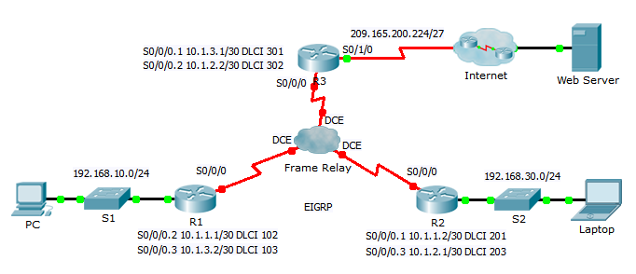

1. Addressing Table

|  |  |  |  |  |
| --- | --- | --- | --- | --- |
| Device | Interface | IP Address | Subnet Mask | Default Gateway |
| R1 | G0/0 | 192.168.10.1 | 255.255.255.0 | N/A |
| S0/0/0.2 | 10.1.1.1 | 255.255.255.252 | N/A |
| S0/0/0.3 | 10.1.3.2 | 255.255.255.252 | N/A |
| R2 | G0/0 | 192.168.30.1 | 255.255.255.0 | N/A |
| S0/0/0.1 | 10.1.1.2 | 255.255.255.252 | N/A |
| S0/0/0.3 | 10.1.2.1 | 255.255.255.252 | N/A |
| R3 | S0/0/0.1 | 10.1.3.1 | 255.255.255.252 | N/A |
| S0/0/0.2 | 10.1.2.2 | 255.255.255.252 | N/A |
| S0/1/0 | 209.165.200.225 | 255.255.255.224 | N/A |
| ISP | S0/0/0 | 209.165.200.226 | 255.255.255.224 | N/A |
| Web | NIC | 209.165.200.2 | 255.255.255.252 | 209.165.200.1 |
| PC | NIC | 192.168.10.10 | 255.255.255.0 | 192.168.10.1 |
| Laptop | NIC | 192.168.30.10 | 255.255.255.0 | 192.168.30.1 |

1. Objectives

Part 1: Configure Frame Relay

Part 2: Configure Frame Relay Point-to-Point Subinterfaces

Part 3: Verify Configuration and Connectivity

1. Scenario

In this activity, you will configure Frame Relay with two subinterfaces on each router to reach the other two routers. You will also configure EIGRP and verify end-to-end connectivity.

1. Configure Frame Relay
   1. Configure Frame Relay encapsulation on the S0/0/0 interface of R1.

R1(config)# **interface s0/0/0**

R1(config-if)# **encapsulation frame-relay**

R1(config-if)# **no shutdown**

* 1. Configure Frame Relay encapsulation on the S0/0/0 interfaces of R2 and R3.
  2. Test connectivity.

From the command prompt on **PC**, verify connectivity to the **Laptop**, located at 192.168.30.10, using the **ping** command.

The ping from **PC** to **Laptop** should fail because the **R1** router does not have to route to reach the 192.168.30.0 network. **R1** must be configured with a Frame Relay on subinterfaces so that it can find the next hop destination to reach that network.

1. Configure Frame Relay Point-to-Point Subinterfaces

Each router requires two subinterfaces to reach the other routers. The DLCIs to reach these routers are provided below.

* 1. Configure subinterfaces on R1, R2, and R3.
     1. Configure **R1** to use subinterfaces. **DLCI 102** is used to communicate from **R1** to **R2**, while **DLCI 103** is used to communicate from **R1** to **R3**.

R1(config)# **interface s0/0/0.2 point-to-point**

R1(config-subif)# **ip address 10.1.1.1 255.255.255.252**

R1(config-subif)# **frame-relay interface-dlci 102**

R1(config-subif)# **interface s0/0/0.3 point-to-point**

R1(config-subif)# **ip address 10.1.3.2 255.255.255.252**

R1(config-subif)# **frame-relay interface-dlci 103**

* + 1. Add network entries to EIGRP autonomous system 1 to reflect the IP addresses above.

R1(config)# **router eigrp 1**

R1(config-router)# **network 10.1.1.0 0.0.0.3**

R1(config-router)# **network 10.1.3.0 0.0.0.3**

* + 1. Configure **R2** to use subinterfaces. **DLCI 201** is used to communicate from **R2** to **R1**, while **DLCI 203** is used to communicate from **R2** to **R3**. Use the correct IP address in the **Address Table** for each subinterface.
    2. Add the appropriate EIGRP entries to **R2** for autonomous system of 1.
    3. Configure **R3** to use subinterfaces. **DLCI 301** is used to communicate from **R3** to **R1**, while **DLCI 302** is used to communicate from **R3** to **R2**. Use the correct IP address for each subinterface.
    4. Add the appropriate EIGRP entries to **R3** for autonomous system of 1.

1. Verify Configuration and Connectivity
   1. Verify the Frame Relay configuration.

Show information about Frame Relay and the connections that have been made. Note the fields for BECN, FECN, DE, DLCI, and LMI TYPE.

R1# **show frame-relay map**

R1# **show frame-relay pvc**

R1# **show frame-relay lmi**

* 1. Verify end-to-end connectivity.

The **PC** and **Laptop** should be able to ping each other and the **Web Server**.